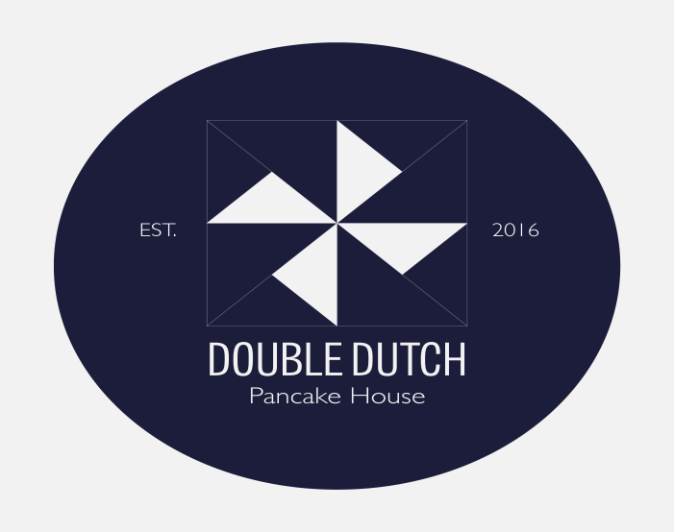
DOUBLE DUTCH PANCAKE HOUSE
York Restaurant Week
£5 Set Menu
+ 1.00 for a Gluten Free pancake
Any sweet pancake with one topping and a drink from the lists below
any base can be made Vegan or Gluten free see Vg or GF against toppings
Toppings Drinks alternative milk +0.40
Golden syrup vg gf Americano
Stroop (Dutch syrup) vg gf Pot of Yorkshire tea
butterscotch sauce vg gf
Hot melted Nutella gf Cooler (Sparkling juice)
Hot melted Biscoff vg Apple, lemon & mango
ice cream vg gf Blackcurrant
Peanut butter vg gf Dragon fruit
Lemon vg gf Watermelon
Honey gf
chocolate sauce vg gf
Jam vg gf
banana vg gf
Add any other sweet topping – see our full menu for options and prices

